**Project Design Phase-II Data Flow Diagram & User Stories**

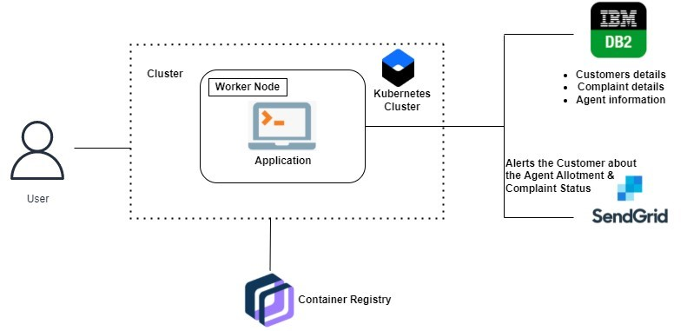

|  |  |
| --- | --- |
| Date | 04 November 2022 |
| Team ID | PNT2022TMID34443 |
| Project Name | Customer Care Registry |
| Maximum Marks | 4 Marks |

**Data Flow Diagrams:**

A Data Flow Diagram (DFD) is a traditional visual representation of the information flows within a system. A neat and clear DFD can depict the right amount of the system requirement graphically. It shows how data enters and leaves the system, what changes the information, and where data is stored.

**User Stories**

|  |  |  |  |  |  |  |
| --- | --- | --- | --- | --- | --- | --- |
| **User Type** | **Functional Requiremen**  **t (Epic)** | **User**  **Story**  **Number** | **User Story / Task** | **Acceptance**  **criteria** | **Priority** | **Release** |
| Customer (Web user) | Registration | USN-1 | As a user, I can register for the application by entering my email, password, and confirming my password. | I can access my account / dashboard | High | Sprint-1 |
|  | Login | USN-2 | As a user, I can log into the  application by entering email &  password | I can access my dashboard | High | Sprint-1 |
|  | Dashboard | USN-3 | After Login | I can view my ticket | High | Sptint-2 |
| Agent | Agent page | USN-4 | As a agent ,I can review customer complaints and assist them | I can access the Agent page | High | Sprint-3 |
| Administrator | Admin page | USN-5 | As an admin, I can allot customers to the agents | I can access the admin page | High | Sprint-4 |